Change Default Font Settings & Styles In Word 2010
by Usman Javaid

Word 2010 default font is Calibri, which is still not that much popular among users, but Word 2010 is flexible enough to let users change the default font settings. In this post we will be guiding you through step-by-step procedure of changing default font settings and styles.
To change default font setting, launch Word 2010, navigate to Home tab and from Font group, click small button at the right-bottom of group area.
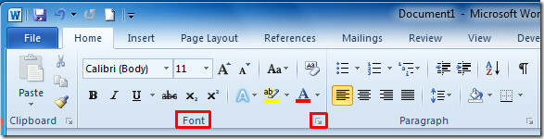
You will reach Font main dialog, start changing default basic settings. From Font select the font, under Font style select desired style and from Size change size for default font.
You can also set some extra font settings such as, Font color, Underline Style and Color. From Effects, enable different font effects options. You can see all the changes in Preview pane.
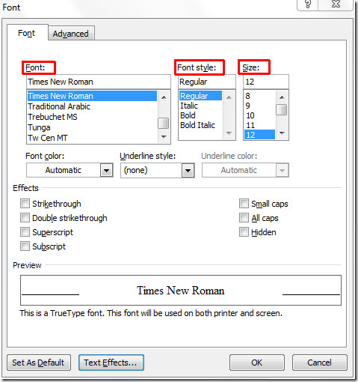
Now click Text Effects, to customize advance effects of font. It will bring up Format Text Effects. From here you can set Text Fill, Text Outline and Outline Style, and apply different Shadow, Reflection styles etc. When done, click Close.

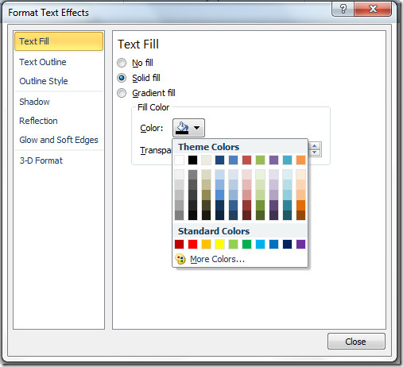
It will bring you back to Font dialog. For configuring advance settings, switch to Advanced tab. Under Character Spacing, change default settings for character spacing and from Open Type Features, you can change different settings for; Ligatures, Number spacing, Number forms, Stylistic sets. Now click Set as default at the bottom to save the changes to default.
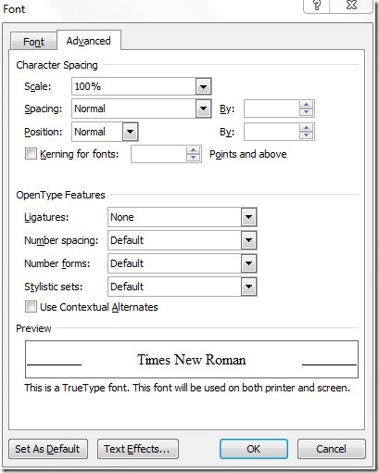
A dialog will appear, now enable All documents based on Normal.dotm template option and click OK.
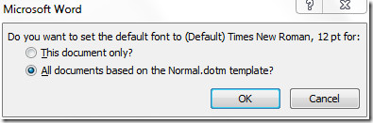
On reopening Word 2010, you will see the new user-selected font and styles.
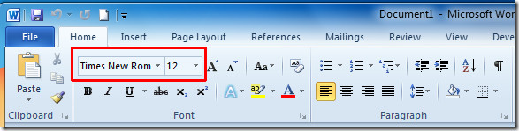
Source: http://www.addictivetips.com/microsoft-office/change-default-font-settings-styles-in-word-2010/

